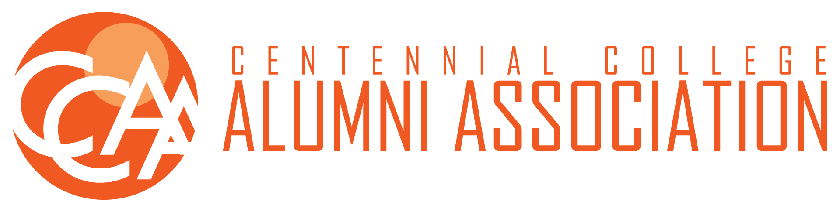  
NOMINATION FORM

Annual General Meeting - June 22, 2024

Centennial College Alumni Association (**“CCAA”**)

The CCAA in accordance with its bylaws hosts an open election for the following positions this year:

* President - Chair
* Vice-President - Finance and Partnerships
* Director of Administration and Services (DAS)
* Director of Special Events and Alumni Engagements (DSEAE)
* Director at Large (2 positions)

Individuals meeting the required criteria (see position descriptions in CCAA Bylaws) may be nominated for the above positions up until the deadline. This represents a nomination from within the board and will supersede nominations from the floor. All nominations received for the CCAA Selections Committee must be completed in full. I, the undersigned, wish to be nominated for the position(s) of:

**President - Chair**  **Vice-President - Finance and Partnerships   
Director of Administration and Services (DAS)   
Director of Special Events and Alumni Engagements (DSEAE)   
Director At Large (x2)**

**NOMINEE INFORMATION:**

Nominee (print):_____________________________________________________________________________

Complete Address of Nominee: _________________________________________________________________

City:_______________________ Province: _______________________ Postal Code: _____________________   
Year of Graduation: _________________________ Program Graduated From: __________________________

Phone (Cell) Number: _______________________ E-mail: __________________________________________

Current Position on the Board and terms served (if any):_____________________________________________

**QUALIFICATION STATEMENTS:**

I am eighteen (18) years of age or older

I have the power under law to contract

I am member of the Association in good standing

I have not been previously removed from a Board position, in accordance with the Bylaws   
I have not been found to be in violation of the Bylaws

I have included a resume, attached to this nomination form

I have served at least one (1) term as a Director **(only applicable for Nominees wishing to be elected for the President-Chair or any of the Vice-President positions)**

To be nominated, the completed intention form and the package must be received no later than June 7th, 2024 at 12:00pm. The package must include a brief paragraph stating your intent and why you would like to be re-nominated, qualifications and a resume with this Nomination form.*

*\*The Selection committee will meet after June 10th 2024 to review the nominations*

**2024 Annual General Meeting**

**June 22th, 2024**

**9:00am**\* **- 11:00am**

*\*Alumni arriving or joining online* ***after*** *meeting is called to order forfeits voting rights.*

Completed intention forms must be returned before the deadline date:

CCAA, C/O Selections Committee

ccaaagm2024@gmail.com